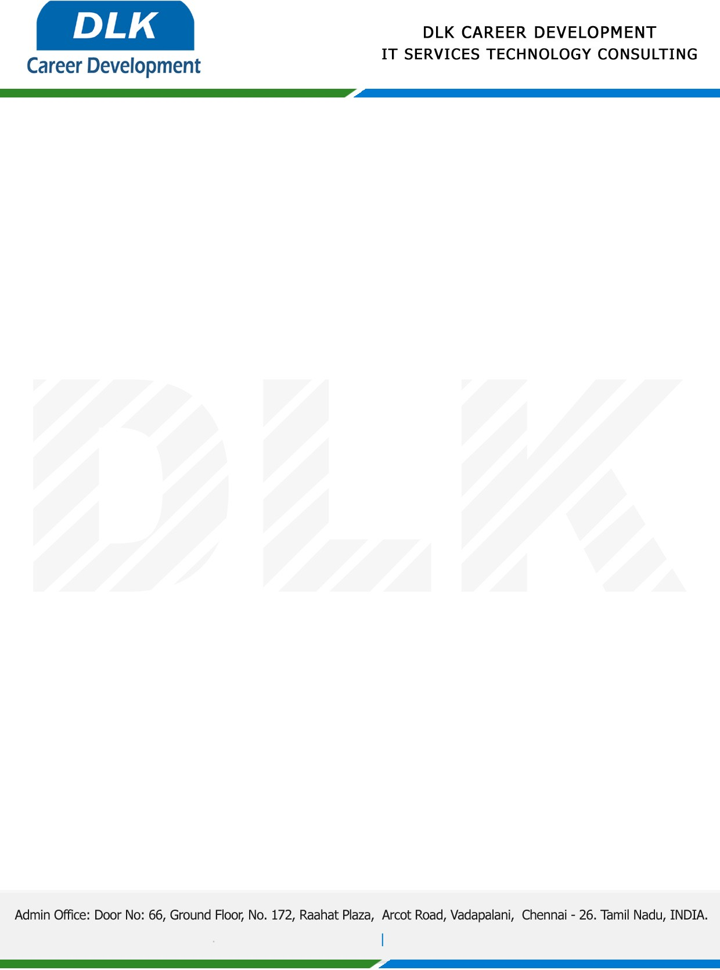

Date: 08 / February / 2023

**To**

Department of MCA (Computer Application),

Head of Department,

Bharathiar University, Coimbatore-641046.

**Sub: Letter of Internship Acceptance**

This is to certify that **MR SATHISKUMAR J (REG NO : 21CSEA28)** final year student of has accepted the project Work duration from **10th February 2023** to **10th April 2023** under the domain **“WEB DEVELOPMENT”.** During the internship, all information and data collected from you should be kept confidential.

We appreciate your interest in **DLK CAREER DEVELOPMENT**

For **DLK CAREER DEVELOPMENT**

**HR Manager**

**VELMURUGAN J**